Sri Venkateswara college of Engineering and Technology(Autonomous)


DEPARTMENT OF COMPUTER SCIENCE AND ENGINEERING(AI&ML)
PROJECT TITLE: AIR QUALITY FORECASTING & POLLUTION RISK ANALYTICS FOR INDIA

STUDENT NAME ROLLNUMBERS
VADDHIREDDY ROHINI 22781A33D8
NITESH KUMAR SAH 22781A33F1
AKULA CHARANTEJ 23785A3301
MANGALA BHAGYASRI 22781A3385
M. CHARAN 23785A3310

Signature of the project guide Signature of the Mentor
Coordinator Dr. Kalpana
Mr. Madhi Madhan L

Abstract

Rapid urbanization, industrial growth, and increasing vehicular emissions have significantly deteriorated air quality across major Indian cities, posing severe risks to public health and environmental sustainability. Traditional air quality monitoring systems are largely retrospective, offering limited capabilities for proactive forecasting, early warning, and localized risk assessment. To address this gap, this project proposes an end-to-end machine learning–based Air Quality Index (AQI) forecasting and pollution risk analytics system designed for city-level and short-term prediction in India.
The system integrates historical AQI records, pollutant concentrations (PM2.5, PM10, NO₂, SO₂, CO, O₃), meteorological variables (temperature, humidity, wind speed, rainfall), and engineered temporal features (cyclical encoding of hour, day-of-week, and month). A time-series–aware data preprocessing pipeline is implemented, including lag feature generation, missing value imputation, feature scaling, and city-wise chronological train–validation–test splitting. Multiple regression models—Linear Regression, Decision Tree Regressor, Random Forest Regressor, and XG Boost—are trained and evaluated using performance metrics such as RMSE, MAE, and R².
To ensure systematic experimentation and reproducibility, the project employs MLflow for experiment tracking, metric logging, artifact storage, and automated best-model selection. City-specific models and visual analytics are generated to quantify pollutant influence, meteorological impact, and geographical variability. A 72-hour AQI forecasting module is implemented to provide short-term predictions, while a rolling-window–based anomaly detection framework identifies sudden pollution spikes and high-risk pollution episodes.
The results demonstrate that ensemble-based models, particularly Random Forest and XG Boost, outperform linear baselines in capturing nonlinear pollutant–weather interactions. Feature importance analysis highlights PM2.5, PM10, temperature, and humidity as dominant contributors to AQI variation. The system further generates interpretable visual outputs, including time-series trends, forecast curves, actual-vs-predicted comparisons, and pollution spike alerts. The best-performing model is registered and serialized for real-time inference deployment via a Flask-based interface.
Overall, the proposed solution provides a scalable, data-driven decision support system for urban air quality management in India. It enables proactive forecasting, localized risk assessment, and early warning dissemination, thereby supporting environmental agencies, policymakers, and citizens in mitigating the adverse impacts of air pollution.

TABLE OF CONTENTS

CHAPTER 1: INTRODUCTION
1.1 Background of the Study
1.2 Problem Statement
1.3 Objectives of the Project
1.4 Scope of the Project
CHAPTER 2: LITERATURE REVIEW
2.1 Existing AQI Monitoring Systems
2.2 Machine Learning in Air Quality Prediction
2.3 Gaps in Existing Research
Chapter 3: System Analysis and Requirements
3.1 Existing System Overview
3.2 Limitations of the Existing System
3.3 Proposed System Architecture
3.4 Functional Requirements
3.5 Non-Functional Requirements
3.6 Use Case Diagram
3.7 Data Flow Diagram (DFD)
Chapter 4: Dataset Description and Exploratory Data Analysis (EDA)
4.1 Data Sources and Collection
4.2 Description of Dataset Attributes
4.3 Data Preprocessing and Cleaning
4.4 Handling Missing Values
4.5 Outlier Detection and Treatment
4.6 Exploratory Data Analysis
4.6.1 AQI Distribution Analysis
4.6.2 Pollutant vs AQI Relationships
4.6.3 Correlation Analysis
4.7 Feature Engineering
4.7.1 Lag Features
4.7.2 Temporal Features
4.7.3 Cyclical Encoding

Chapter 5: Methodology and System Design
5.1 Overall Workflow of the System
5.2 Data Splitting Strategy (Train–Validation–Test)
5.3 Feature Scaling and Normalization
5.4 Model Selection Criteria
5.5 Machine Learning Models Implemented
5.5.1 Linear Regression
5.5.2 Decision Tree Regression
5.5.3 Random Forest Regression
5.5.4 XGBoost Regression
5.6 Time-Series Forecasting Horizon (24h, 48h, 72h)
5.7 Hyperparameter Tuning
5.8 Model Training Process
5.9 Experiment Tracking using MLflow
5.10 GenAI(LLM/RAG)

CHAPTER 6: CONCLUSION & FUTURE SCOPE
6.1 Conclusion
6.2 Limitations
6.3 Future Enhancements

Chapter-01
INTRODUCTION
1.1 Background of the Study:
Air pollution has become a major environmental and public health concern due to rapid urbanization, industrial growth, and increased vehicular emissions. Poor air quality can lead to serious health issues such as respiratory diseases, cardiovascular problems, and reduced life expectancy.
The Air Quality Index (AQI) is a standardized measure used to represent air pollution levels and their impact on human health. Predicting AQI in advance using machine learning techniques helps authorities and citizens take preventive actions and improve environmental management.
1.2 Problem Statement:
Traditional air quality monitoring systems mainly provide real-time or historical AQI values, but they lack accurate forecasting capabilities. Sudden changes in pollution levels make it difficult to warn the public in advance.
There is a need for an efficient system that can analyze historical pollution and weather data and accurately predict future AQI values to support early warnings and decision-making.
1.3 Objectives of the Project:
The main objectives of this project are:
- To analyze historical air pollution and meteorological data.
- To perform exploratory data analysis (EDA) to understand AQI patterns.
- To build machine learning models for AQI prediction.
- To compare different regression models and select the best-performing one.
- To forecast AQI values for short-term horizons (24–72 hours).
1.4 Scope of the Project:
The scope of this project includes the development of an AQI forecasting system using traditional machine learning models. The system focuses on short-term AQI prediction based on historical data and selected environmental parameters.
It does not include real-time data streaming or deep learning methods but provides a scalable foundation that can be extended in the future with additional data sources and advanced features.

Chapter-2
LITERATURE REVIEW
2.1 Existing AQI Monitoring Systems:
Existing Air Quality Index (AQI) monitoring systems are primarily designed to measure and report current air pollution levels. Government agencies such as pollution control boards use fixed monitoring stations equipped with sensors to collect data on major pollutants like PM2.5, PM10, NO₂, SO₂, CO, and O₃. These systems provide real-time or near real-time AQI values to the public through websites and mobile applications.
While these systems are effective for continuous monitoring, they are largely reactive in nature. They mainly focus on displaying current or historical AQI values and lack predictive capabilities. As a result, warnings are issued only after air quality has already deteriorated, limiting the time available for preventive measures.
2.2 Machine Learning in Air Quality Prediction:
Machine learning techniques have been increasingly used to improve AQI prediction by analyzing historical air quality and meteorological data. Traditional machine learning models such as Linear Regression, Decision Trees, Random Forest, and Gradient Boosting methods are widely applied to identify patterns and relationships between pollutants and AQI.
These models can handle large datasets, capture non-linear relationships, and provide better forecasting accuracy compared to simple statistical methods. By learning from past data, machine learning models enable short-term AQI forecasting, helping authorities and individuals prepare for potential pollution episodes.
2.3 Gaps in Existing Research:
Despite advancements in AQI prediction, several research gaps still exist. Many existing studies focus mainly on real-time AQI reporting rather than proactive forecasting. Limited attention is given to short-term prediction horizons that are crucial for early warning systems.
Additionally, some studies do not sufficiently analyze the relative impact of different pollutants and meteorological factors on AQI. Lack of proper feature engineering and interpretability also limits practical implementation. There is a need for a comprehensive, interpretable, and scalable machine learning-based AQI forecasting system that can support effective decision-making and pollution control strategies.

Chapter-03

SYSTEM ANALYSIS AND REQUIREMENTS

3.1 Existing System Overview:
The existing air quality monitoring systems are mainly designed to measure and display current AQI values using fixed monitoring stations. These systems collect pollutant data such as PM2.5, PM10, NO₂, SO₂, CO, and O₃ and publish AQI information through dashboards and reports. Most systems focus on real-time monitoring and historical data visualization, helping users understand current pollution levels in different locations.
However, these systems do not actively analyze trends or predict future AQI values. They function as information providers rather than decision-support systems, offering limited assistance for early warnings or pollution control planning.
3.2 Limitations of the Existing System:
The existing systems have several limitations:
- They provide reactive information, alerting users only after pollution levels become high.
- There is no forecasting capability to predict AQI in advance.
- Limited use of data analytics and machine learning techniques.
- Lack of personalized or city-specific predictive insights.
- Inability to detect sudden pollution spikes beforehand.
These limitations reduce the effectiveness of existing systems in supporting proactive air quality management.
3.3 Proposed System Architecture:
The proposed system introduces a machine learning–based AQI forecasting architecture. It consists of modules for data collection, preprocessing, feature engineering, model training, prediction, and result visualization. Historical air quality and meteorological data are processed and used to train regression models such as Linear Regression, Decision Tree, Random Forest, and XGBoost.
The trained models generate short-term AQI forecasts, which are then delivered to users through a simple interface or chatbot. The system is designed to be modular, scalable, and deployment-ready.
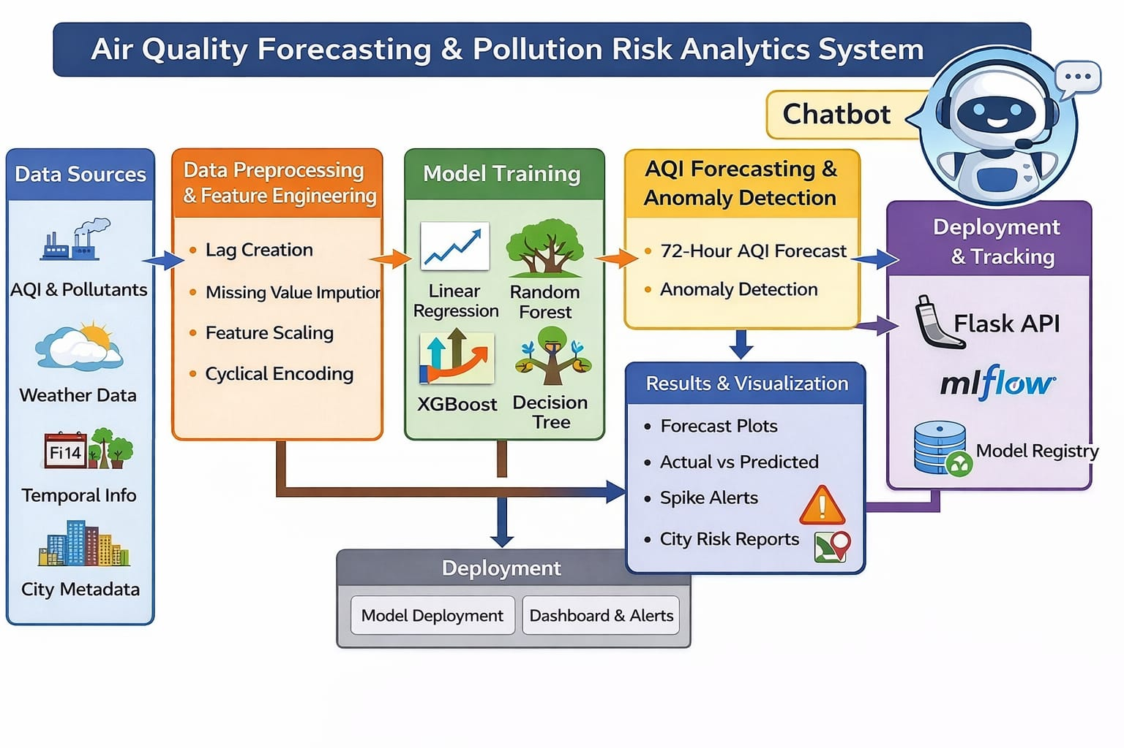
This diagram represents the end-to-end workflow of the Air Quality Forecasting & Pollution Risk Analytics System.
- Data Sources:
AQI, pollutant levels, weather data, temporal information, and city metadata are collected and versioned using DVC.
- Data Preprocessing & Feature Engineering:
The data is cleaned, missing values are handled, features are scaled, lag features are created, and cyclical encoding is applied.
- Model Training:
Multiple models (Linear Regression, Decision Tree, Random Forest, XGBoost) are trained and tracked using MLflow.
- AQI Forecasting & Anomaly Detection:
The system generates 72-hour AQI forecasts and detects pollution spikes using statistical methods.
- Results & Visualization:
Forecast plots, spike alerts, and city-wise risk reports are generated. GenAI creates natural-language summaries.
- Deployment & Tracking (MLOps):
Models are versioned with MLflow, data is tracked using DVC, and pipelines automate retraining and deployment.
- Final Output:
Users receive AQI predictions, alerts, and GenAI-based risk insights through dashboards.
3.4 Functional Requirements:
The functional requirements define what the system should do:
- Collect and load historical AQI and pollutant data.
- Preprocess data by handling missing values and noise.
- Perform exploratory data analysis and feature engineering.
- Train and evaluate multiple machine learning models.
- Predict AQI for future time horizons (24–72 hours).
- Display AQI predictions and alerts to users.
- Store trained models and prediction results.
3.5 Non-Functional Requirements:
Non-functional requirements describe how the system performs:
- Performance: The system should provide predictions within acceptable response time.
- Scalability: It should support multiple cities and large datasets.
- Reliability: Predictions should be consistent and reproducible.
- Usability: The interface should be simple and user-friendly.
- Maintainability: The system should allow easy updates and model retraining.
3.6 Use Case Diagram:
The use case diagram represents interactions between users and the system. Users can request AQI forecasts, view pollution trends, and receive alerts. The system processes the request, applies the trained machine learning model, and returns AQI predictions and warnings. Administrators or developers can update datasets, retrain models, and manage system configurations.
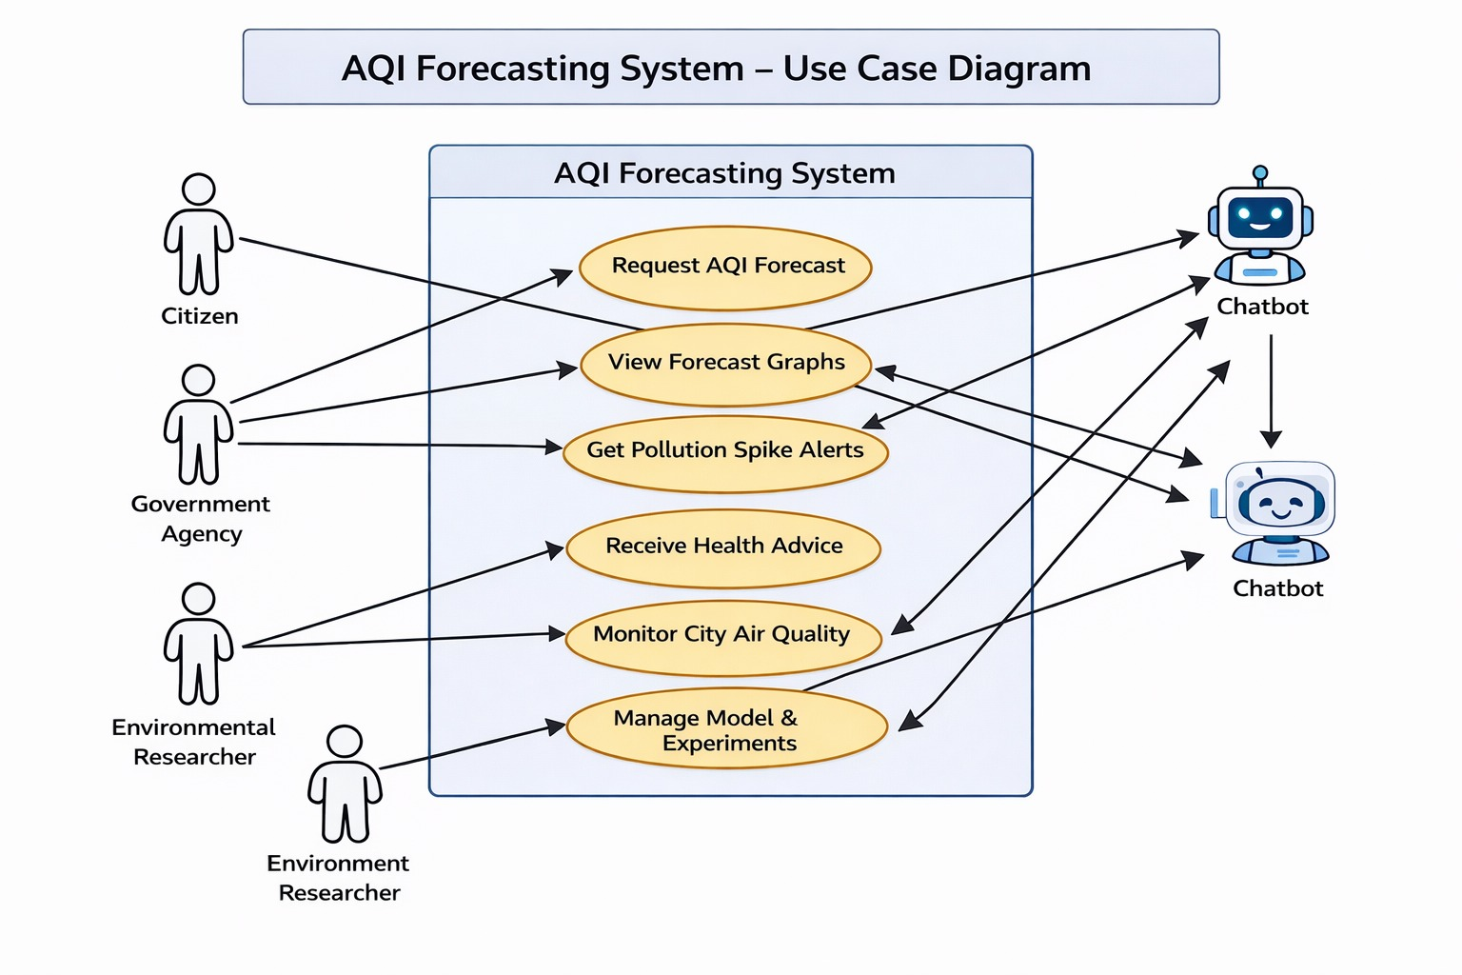
Overall, the use case diagram shows that the AQI Forecasting System supports multiple user roles with different objectives, ranging from public awareness and health protection to policy support and scientific research. By integrating forecasting, visualization, alerts, and chatbot-based interaction, the system ensures effective communication of air quality information and enables proactive air pollution management.

3.7 Data Flow Diagram (DFD):
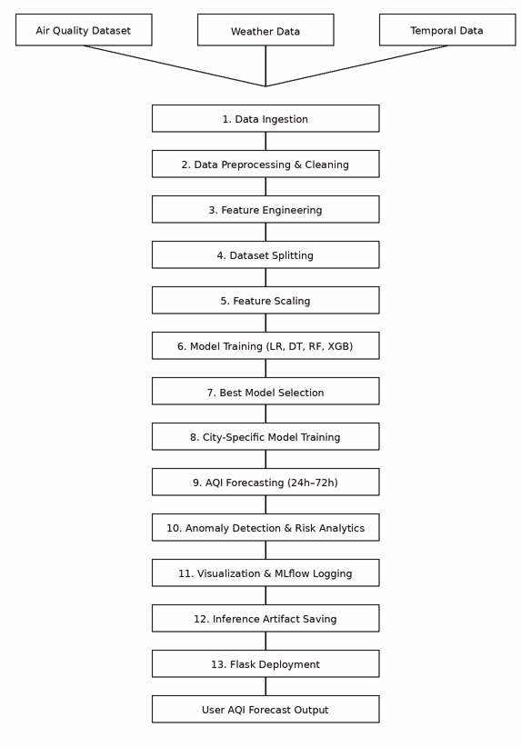
The Data Flow Diagram illustrates how data moves through the system. Pollution and weather data flow into the preprocessing module, where data cleaning and feature engineering are performed. The processed data is sent to the machine learning models for training and prediction. The output AQI values are stored and presented to users as reports or alerts. The DFD clearly shows the transformation of raw data into meaningful AQI forecasts.

Chapter-04

Dataset Description and Exploratory Data Analysis (EDA)

4.1 Data Sources and Collection:
The dataset was collected from publicly available air quality monitoring sources, containing historical AQI values, pollutant concentrations, and meteorological data for multiple Indian cities. Data was gathered over several months/years to capture seasonal and temporal pollution patterns.
4.2 Description of Dataset Attributes:
The dataset includes features such as AQI, PM2.5, PM10, NO₂, SO₂, CO, O₃, temperature, humidity, wind speed, rainfall, date, hour, and city name. These attributes help model the relationship between environmental factors and air quality levels.
4.3 Data Preprocessing and Cleaning:
Raw data was cleaned by removing duplicate records, correcting inconsistent formats, converting date and time fields into standard datetime format, and ensuring all numerical fields were properly typed for analysis.
4.4 Handling Missing Values:
Missing values in pollutant and weather variables were handled using mean imputation to maintain dataset size and prevent bias. Records with excessive missing values were removed to ensure data quality.
4.5 Outlier Detection and Treatment:
Outliers were detected using statistical methods such as interquartile range (IQR) and visual inspection through box plots. Extreme values caused by sensor errors were either capped or removed to reduce model distortion.
4.6 Exploratory Data Analysis (EDA):
Exploratory Data Analysis (EDA) is a crucial step in the AQI forecasting system as it helps in understanding the underlying structure, patterns, trends, and relationships present in the air quality dataset. In this project, EDA was performed using visualizations and statistical techniques to analyze AQI behavior, pollutant influence, and inter-feature relationships. The analysis guided feature selection and model design for accurate AQI prediction.
4.6.1 AQI Distribution Analysis:
The AQI distribution plot shows how frequently different AQI values occur in the dataset.
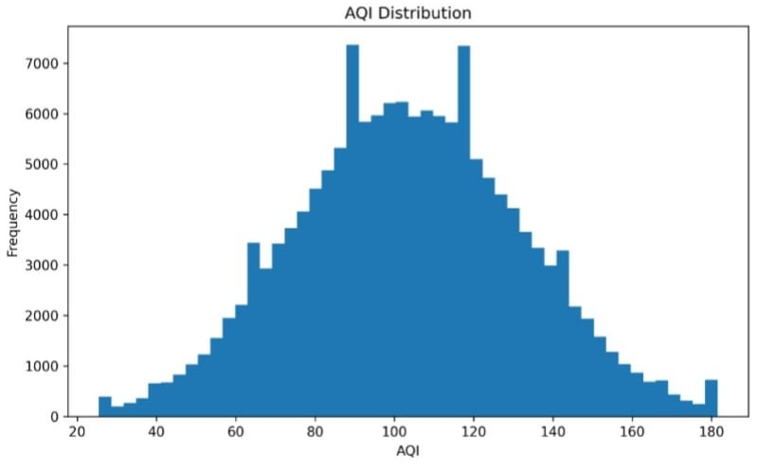
Observations:
- The AQI values range approximately from 25 to 180, covering categories from Good to Unhealthy.
- The distribution follows a near-normal (bell-shaped) pattern, with a higher concentration of values between 80 and 120.
- This indicates that moderate air quality conditions are most common in the dataset.
- Very low AQI (clean air) and extremely high AQI (severely polluted air) values occur less frequently, forming the tails of the distribution.
Interpretation:
- Since the AQI distribution is relatively balanced and continuous, regression-based machine learning models are suitable.
- The absence of extreme skewness reduces the need for heavy transformations.
- The spread of AQI values ensures that the model learns patterns across multiple pollution levels.

4.6.2 Pollutant vs AQI Relationships:
The scatter plot between PM2.5 concentration and AQI:
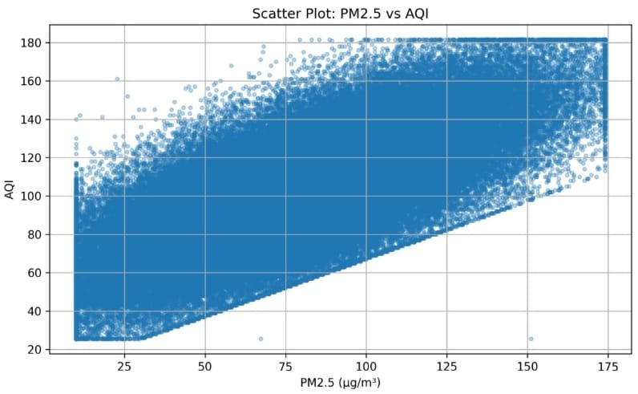
Observations:
- As PM2.5 concentration increases, AQI values also increase consistently.
- The points form a dense, upward-sloping pattern, indicating a strong positive linear relationship.
- At higher PM2.5 levels (above ~100 µg/m³), AQI reaches unhealthy ranges.
- Slight dispersion at higher concentrations indicates the influence of additional pollutants and meteorological factors.
Interpretation:
- PM2.5 is a dominant contributor to AQI, especially during high pollution periods.
- This confirms the environmental fact that fine particulate matter has a significant impact on air quality.
- PM2.5 is therefore a critical feature for AQI prediction models.

Correlation diagram of features:

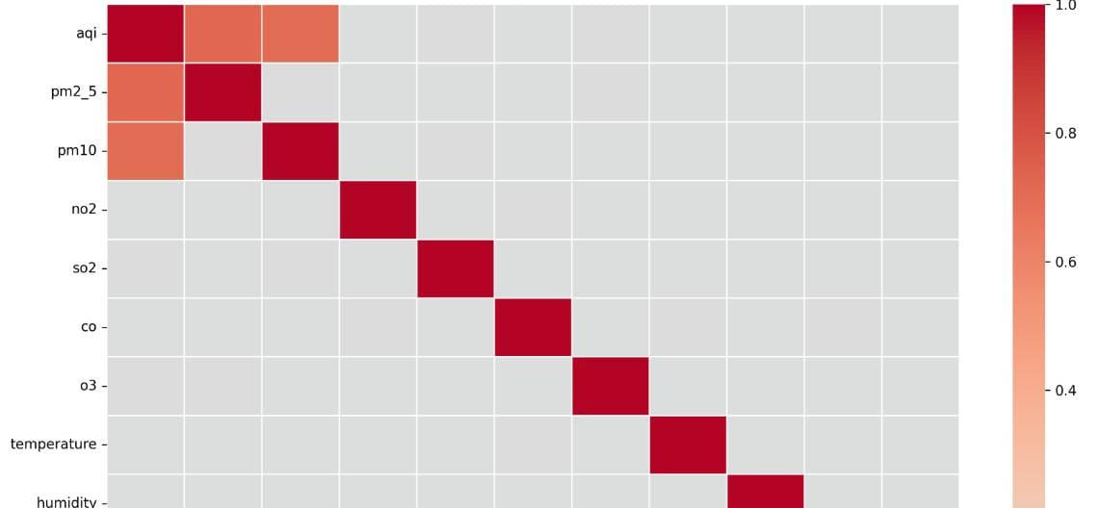

- Similar to PM2.5, PM10 also shows a positive correlation with AQI.
- PM10 represents coarse particulate matter and contributes to AQI, though slightly less strongly than PM2.5.
Other Pollutants vs AQI
- Gases such as NO₂, SO₂, CO, and O₃ show very weak or negligible direct relationships with AQI in this dataset.
- This suggests that AQI variations are more influenced by particulate matter than gaseous pollutants in the observed region and time period.
4.6.3 Correlation Analysis:
Correlation analysis was performed to quantify the strength and direction of relationships between AQI and other variables.
Correlation Values with AQI:
- PM2.5: 0.7189
- PM10: 0.6966
- O₃: 0.0058
- SO₂: 0.0041
- Temperature: 0.0013
- Humidity: 0.0005
- NO₂: -0.0004
- Wind Speed: -0.0004
- Rainfall: -0.0017
- CO: -0.00
Interpretation:
- PM2.5 and PM10 show strong positive correlations with AQI, confirming they are the most influential pollutants.
- All other features have correlations close to zero, indicating weak linear relationships with AQI.
- Slight negative correlations for wind speed and rainfall suggest that higher wind or rain may help disperse pollutants, marginally improving air quality.
Correlation Heatmap Analysis:
Basic Correlation Heatmap:
- AQI shows strong correlation blocks with PM2.5 and PM10.
- Minimal correlation is observed between AQI and meteorological variables.
- Low inter-correlation among many features reduces multicollinearity issues.
Key Insights from EDA
- Particulate matter (PM2.5 and PM10) is the primary driver of AQI.
- AQI exhibits a stable distribution suitable for supervised learning.
- Meteorological factors indirectly influence AQI and become more useful when combined with other features.
- Feature engineering significantly enhances the predictive potential of the dataset.
- EDA validates the choice of machine learning models such as Linear Regression, Random Forest, and XGBoost..
4.7 Feature Engineering
New features were created to improve model performance by capturing temporal patterns and historical dependencies.
4.7.1 Lag Features
Lagged pollutant values (e.g., PM2.5 at previous 6 hours) were added to model time-series behavior and improve short-term AQI prediction accuracy.
4.7.2 Temporal Features
Time-based features such as hour of day, day of week, and month were extracted to capture daily and seasonal pollution trends.
4.7.3 Cyclical Encoding
Cyclical encoding using sine and cosine transformations was applied to hour and month features to preserve periodic patterns in time-based data.

Chapter-05

Methodology and System Design

This chapter explains the complete methodology adopted for designing, training, and evaluating the Air Quality Index (AQI) Forecasting System. It covers the system workflow, data preparation techniques, model selection, training procedures, forecasting horizons, and experiment tracking mechanisms used to ensure reliable and reproducible results.
5.1 Overall Workflow of the System:
The AQI forecasting system follows a structured, end-to-end machine learning workflow to convert raw air quality data into accurate AQI predictions.
Workflow Steps:
- Data Collection
Air pollution and meteorological data (PM2.5, PM10, gases, temperature, humidity, etc.) are collected from the dataset.
- Data Preprocessing
Missing values are handled, noise is reduced, and inconsistent records are removed to improve data quality.
- Exploratory Data Analysis (EDA)
Statistical analysis and visualizations are used to understand AQI trends, pollutant relationships, and correlations.
- Feature Engineering
Lag features, ratios, interaction features, and temporal variables are created to enhance predictive performance.
- Data Splitting
The dataset is divided into training, validation, and testing sets.
- Feature Scaling
Numerical features are normalized or standardized to improve model convergence.
- Model Training
Multiple machine learning models are trained using the prepared data.
- Model Evaluation
Models are evaluated using metrics such as RMSE, MAE, and R² score.
- Experiment Tracking
MLflow is used to track experiments, parameters, metrics, and model versions.
5.2 Data Splitting Strategy (Train–Validation–Test):
To ensure unbiased model evaluation and prevent data leakage, the dataset is divided into three subsets:
- Training Set (≈70%)
Used to train machine learning models.
- Validation Set (≈15%)
Used for hyperparameter tuning and model selection.
- Test Set (≈15%)
Used only for final model performance evaluation.
Importance:
- Helps detect overfitting and underfitting.
- Ensures the model generalizes well to unseen data.
- Maintains fairness in performance comparison across models.
For time-series forecasting, splitting is done chronologically to preserve temporal order.
5.3 Feature Scaling and Normalization:
Feature scaling is essential because pollutant concentrations and meteorological values exist on different scales.
Techniques Used:
- Standardization (Z-score normalization)
Benefits:
- Improves convergence speed for gradient-based models.
- Prevents features with large values from dominating smaller ones.
- Enhances performance of Linear Regression and XGBoost models.
Tree-based models like Random Forest are less sensitive but scaling ensures uniformity across experiments.
5.4 Model Selection Criteria:
Models were selected based on the following criteria:
- Ability to handle non-linear relationships
- Robustness to noise and outliers
- Interpretability
- Computational efficiency
- Proven performance in regression tasks
Multiple models were evaluated to identify the best performer for AQI forecasting.
5.5 Machine Learning Models Implemented:
5.5.1 Linear Regression:
Linear Regression establishes a linear relationship between AQI and input features.
- Acts as a baseline model
- Easy to interpret
- Performs well when relationships are approximately linear
Limitation:
Cannot capture complex non-linear pollutant interactions.
5.5.2 Decision Tree Regression:
Decision Tree Regression splits data into decision rules based on feature thresholds.
- Captures non-linear patterns
- Easy to visualize
- Handles feature interactions naturally
Limitation:
Prone to overfitting if not properly constrained.
5.5.3 Random Forest Regression:
Random Forest is an ensemble of multiple decision trees.
- Reduces overfitting through averaging
- Handles high-dimensional data effectively
- Robust to noise and missing values
Advantage:
Provides stable and accurate predictions for AQI data.
5.5.4 XGBoost Regression:
XGBoost is a gradient boosting algorithm optimized for speed and performance.
- Learns complex non-linear patterns
- Handles missing values automatically
- Includes regularization to reduce overfitting
Result:
XGBoost showed the best overall performance in AQI prediction.
5.6 Time-Series Forecasting Horizon (24h, 48h, 72h):
The system forecasts AQI for different future time horizons:
- 24 hours ahead – Short-term prediction
- 48 hours ahead – Medium-term prediction
- 72 hours ahead – Long-term prediction
Importance:
- Helps government agencies issue early warnings
- Assists citizens in health planning
- Supports pollution control strategies
Lag features are used to incorporate historical AQI and pollutant values.
5.7 Hyperparameter Tuning:
Hyperparameter tuning is performed to optimize model performance.
Techniques Used:
- Grid Search
- Manual parameter selection based on validation performance
Examples:
- Number of trees in Random Forest
- Maximum tree depth
- Learning rate in XGBoost
- Number of estimators
Benefit:
- Improves accuracy
- Reduces overfitting
- Enhances model stability

5.8 Model Training Process:
The training process follows these steps:
- Load preprocessed and scaled data
- Train models using the training set
- Validate models using the validation set
- Fine-tune hyperparameters
- Evaluate final performance on the test set
Evaluation Metrics Used:
- Mean Absolute Error (MAE)
- Root Mean Squared Error (RMSE)
- R² Score
5.9 Experiment Tracking using MLflow:
MLflow is used to manage and track machine learning experiments.
Features of MLflow:
- Logs model parameters
- Tracks evaluation metrics
- Stores trained models
- Enables experiment comparison
- Selection of the best model
Advantages:
- Ensures reproducibility
- Simplifies model versioning
- Helps select the best performing model
Each experiment run stores:
- Model type
- Performance metrics
- Timestamp and run ID

5.10 GenAI (LLM / RAG)
The system uses GenAI with the Gemini Large Language Model (LLM) to provide conversational AQI insights. The LLM is connected to a custom tool that fetches real-time pollution and weather data, predicts AQI using a trained model, and returns the results.
When a user asks about air quality in a city, the LLM automatically calls the tool, interprets the AQI value and pollutant levels, and generates natural-language explanations and health advice based on CPCB India standards.
Instead of a full vector-database RAG system, the model uses live contextual data (AQI values, pollutants, weather, and time features) and system instructions to ensure fact-based, real-time, and explainable responses.
Summary
This chapter presents a systematic methodology for AQI forecasting using machine learning. The combination of robust preprocessing, feature engineering, multiple regression models, and experiment tracking ensures reliable and accurate air quality predictions.

Chapter-06

CONCLUSION & FUTURE SCOPE

This chapter presents the conclusion of the AQI Forecasting System, discusses its limitations, and outlines possible future enhancements based only on traditional machine learning techniques used in this project.
6.1 Conclusion:
The Air Quality Index (AQI) Forecasting System developed in this project successfully demonstrates the application of machine learning techniques for predicting air quality levels using historical pollution and meteorological data. The system includes a complete pipeline consisting of data collection, preprocessing, exploratory data analysis, feature engineering, model training, and evaluation.
Exploratory Data Analysis revealed that PM2.5 and PM10 are the most influential pollutants affecting AQI values, which was also confirmed through correlation analysis. Feature engineering techniques such as lag features and temporal attributes improved the model’s ability to learn time-based patterns in AQI variations.
Multiple machine learning models—Linear Regression, Decision Tree Regression, Random Forest Regression, and XGBoost Regression—were implemented and compared. Ensemble models like Random Forest and XGBoost showed better performance due to their ability to capture non-linear relationships between pollutants and AQI.
Overall, the system provides accurate short-term AQI forecasts, which can help government agencies, researchers, and the general public take preventive measures against air pollution.
6.2 Limitations:
Although the system performs well, it has some limitations:
- Dependence on Historical Data
The forecasting accuracy depends on the availability and quality of historical AQI and pollution data.
- Limited Real-Time Capability
The system currently operates on pre-collected datasets and does not support real-time AQI prediction.
- Single-Location Focus
Spatial variations across multiple monitoring stations are not considered, which may affect large-area predictions.
- External Environmental Factors
Sudden environmental events such as dust storms or industrial accidents are difficult to predict using historical data alone.
- Model Interpretability
While ensemble models provide higher accuracy, they are less interpretable compared to simple linear models.
6.3 Future Enhancements:
The system can be enhanced in the following ways without introducing deep learning:
- Real-Time Data Integration
Incorporating live air quality and weather data from sensors and government APIs can improve prediction accuracy.
- Advanced Feature Engineering
Additional features such as rolling averages, seasonal indicators, and pollution ratios can further enhance model performance.
- Spatial Expansion
Extending the system to handle multiple cities or monitoring stations can make it more scalable.
- Alert and Notification System
The system can be integrated with alert mechanisms to notify users when AQI exceeds safe thresholds.
- Explainable Machine Learning
Feature importance analysis can be added to help users understand how different pollutants impact AQI predictions.

